1. Given an array nums of size n, return the majority element.

The majority element is the element that appears more than ⌊n / 2⌋ times. You may assume that the majority element always exists in the array.

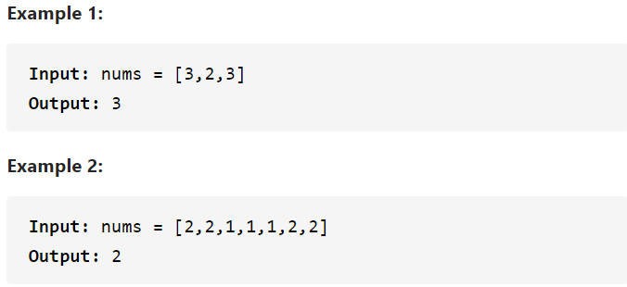

**Note: you can input the length n of the array**

1. Given an integer numRows, return the first numRows of Pascal's triangle.

In Pascal's triangle, each number is the sum of the two numbers directly above it as shown:

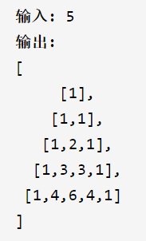

1. A magic index in an array A[0...n-1] is defined to be an index such that A[i] = i. Given a sorted array of integers, write a method to find a magic index, if one exists, in array A. If not, return -1. If there are more than one magic index, return the smallest one.

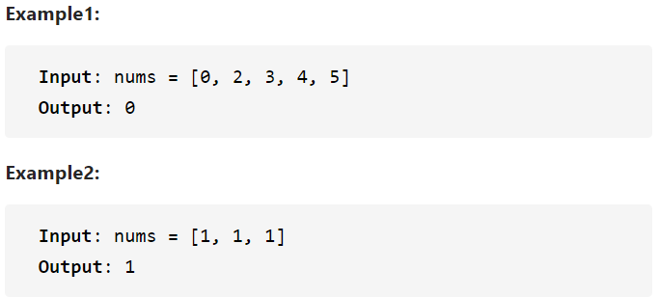

**Note: you can input the length n of the array**

（Optional）

4. a. Store the following data in a file, or use the numbers.dat file provided on this book’s Web site.

5 96 87 78 93 21 4 92 82 85 87 6 72 69 85 75 81 73

b. Write a C++ program to calculate and display the average of each group of numbers in the file created in Exercise a. The data is arranged in the file so that each group of numbers is preceded by the number of data items in the group. Therefore, the first number in the file, 5, indicates that the next five numbers should be grouped together. The number 4 indicates that the following four numbers are a group, and the 6 indicates that the last six numbers are a group. (*Hint*: Use a nested loop. The outer loop should terminate when the end of file has been encountered.)

（Optional）

5. a. You have collected information about cities in your state. You decide to store each city’s name, population, and mayor in a file. Write a C++ program to accept data for a number of cities from the keyboard and store the data in a file in the order in which it’s entered.

b. Read the file created in a., sort the data alphabetically by city name, and display the data.